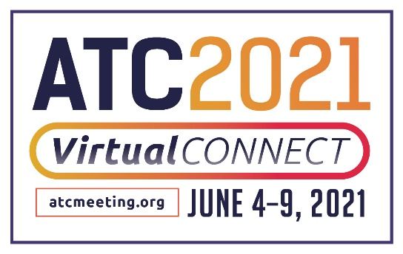

ABOUT THE AMERICAN TRANSPLANT CONGRESS (ATC)

What is the American Transplant Congress (ATC)?
The ATC is the annual joint meeting of the American Society of Transplant Surgeons (ASTS) and the American Society of Transplantation (AST), both non-profit medical associations for professionals involved in scientific research and advocacy related to the advancement of transplantation.

What is ATC 2021 Virtual Connect?
ATC 2021 Virtual Connect, is the ATC’s new, enhanced virtual meeting experience for transplantation professionals taking place June 4-9, 2021. This year’s all-virtual format will feature a robust program of new scientific and clinical information, discussions around care and management, and socioeconomic, ethical, and regulatory issues relevant to organ and tissue transplantation. This year’s program will also feature new COVID-19 content pertinent to the field of transplantation.

Who attends the ATC?
The Congress is designed for physicians, surgeons, scientists, nurses, organ procurement personnel, pharmacists and other transplant professionals interested in solid organ and tissue transplantation. (Journalists wishing to cover the Congress may register HERE.)

The ATC 2021 Virtual Connect Program Features:

IMPACT SESSIONS
Industry innovators will explore how the transplant industry is transforming to pave the way for tomorrow’s advancements. Attendees can expect to leave these sessions armed with cutting-edge information on the future of the industry.

IN-DEPTH SYMPOSIA
For the first year, In-Depth Symposia is included in ATC registration and will be held June 4. Sessions span the range of issues facing transplant professionals.

EXPERT VIP MEET-UPS*
Live Video Discussion, Question and Answer sessions provide exclusive access to Mentor Experts in the field, and take place in an intimate discussion setting, with no formal slide presentations. The purposeful layout is designed to allow interaction and discussion while creating new connections.
*Session attendance is limited to 50 attendees.

WOMEN'S NETWORKING EVENT
This year’s ATC virtual format networking event for women in transplantation will go beyond the curriculum to discuss strategies to achieve personal and professional success. Discussion topics are interactive, conversational with no formal slides. Each topic will have 15 minutes of live video conversation facilitated by women leaders in the field.

What is the American Society of Transplant Surgeons?
The American Society of Transplant Surgeons (ASTS) represents approximately 1,900 professionals dedicated to excellence in transplantation surgery. Our mission is to advance the art and science of transplant surgery through patient care, research, education, and advocacy. To learn more, visit ASTS.org.

What is the American Society of Transplantation?
The American Society of Transplantation (AST) represents more than 4,000 transplantation professionals
dedicated to advancing the field and improving patient care by promoting research, education, advocacy, and organ donation. The AST’s diverse membership includes physicians, surgeons, scientists, nurses, allied health professionals, and administrators. For more information about the AST, please visit myAST.org.

ATC Media Contact:
Julia Brannan-Rauch
julia@mojjocc.com
201-725-7375

AST Media Contact:
Shauna O’Brien, MBA
sobrien@myAST.org
856-642-4433

ASTS Media Contact:
Diane Mossholder, MA, CAE
Diane.mossholder@asts.org

